Architectural Components - Model

📝Definition
# Source: AI Source: Provided by: [Data Path: Persons Table -> ID Column: 1, Name_En Column: Motasem Essam] -> From: [ChatGPT] on [1/23/2026]
The Model represents the data and business logic of the application. It is responsible for managing the state, rules, and core behavior of the system.
👉 The Model is the heart of the application — it knows the data and how it should behave.

🔑 Responsibilities of Model
# Source: AI Source: Provided by: [Data Path: Persons Table -> ID Column: 1, Name_En Column: Motasem Essam] -> From: [ChatGPT] on [1/23/2026]
- Store and manage application data
- Implement business rules and logic
- Validate data
- Interact with data sources (via Repository or Data layer)
- managing the state, rules, and core behavior of the system

1️⃣ Managing the State
# Source: AI Source: Provided by: [Data Path: Persons Table -> ID Column: 1, Name_En Column: Motasem Essam] -> From: [ChatGPT] on [1/23/2026]
- What it means: The Model stores and keeps track of the current data of the application.
- Example: In a shopping cart app, the Model holds:
  - Items added to the cart
  - Quantities
  - Prices
- Why it matters: The UI and other components rely on the Model to know the current data.
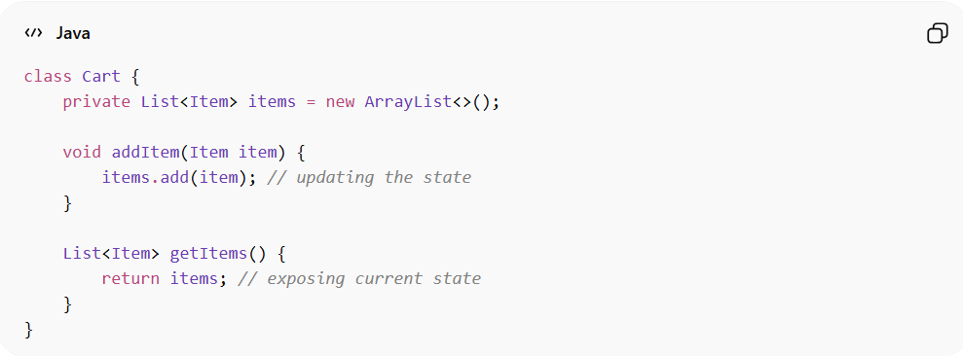
class Cart {
private List<Item> items = new ArrayList<>();

void addItem(Item item) {
items.add(item); // updating the state
}

List<Item> getItems() {
return items; // exposing current state
}
}

2️⃣ Managing the Rules
# Source: AI Source: Provided by: [Data Path: Persons Table -> ID Column: 1, Name_En Column: Motasem Essam] -> From: [ChatGPT] on [1/23/2026]
- What it means: The Model enforces business logic and constraints — what is allowed and what is not.
- Example:
  - A user cannot place an order if the cart is empty
  - Age must be ≥ 18 for registration
- Why it matters: This ensures the system behaves correctly according to the business requirements.
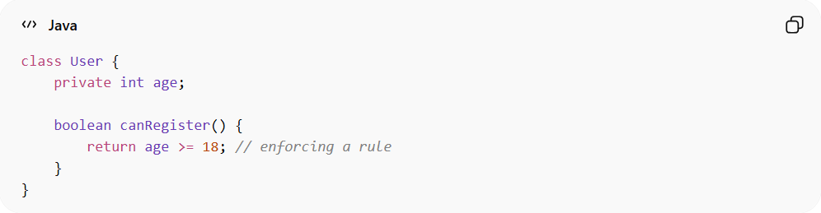
class User {
private int age;

boolean canRegister() {
return age >= 18; // enforcing a rule
}
}

3️⃣ Core Behavior of the System
# Source: AI Source: Provided by: [Data Path: Persons Table -> ID Column: 1, Name_En Column: Motasem Essam] -> From: [ChatGPT] on [1/23/2026]
- What it means: The Model defines the key actions or operations the system can perform on the data.
- Example:
  - Calculating total order price
  - Applying discounts
  - Processing a payment
- Why it matters: The Model drives the main functionality of the application — it’s the “engine” of the system.
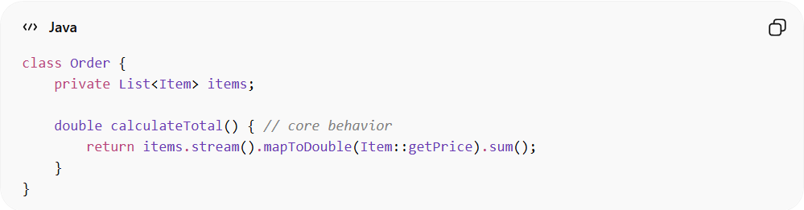
class Order {
private List<Item> items;

double calculateTotal() { // core behavior
return items.stream().mapToDouble(Item::getPrice).sum();
}
}

🔑 Key Idea
# Source: AI Source: Provided by: [Data Path: Persons Table -> ID Column: 1, Name_En Column: Motasem Essam] -> From: [ChatGPT] on [1/23/2026]
The Model is not just a container for data — it owns the state, enforces rules, and provides the main behaviors that make the system work.

🔑 Types of Models

1️⃣ Entity Model
# Source: AI Source: Provided by: [Data Path: Persons Table -> ID Column: 1, Name_En Column: Motasem Essam] -> From: [ChatGPT] on [1/23/2026]
Represents objects with identity and lifecycle
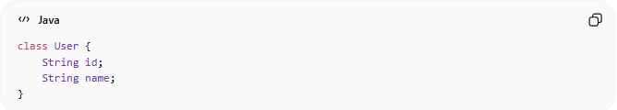
class User {
String id;
String name;
}
✅ Has ID
✅ Changes over time

2️⃣ Value Object Model
# Source: AI Source: Provided by: [Data Path: Persons Table -> ID Column: 1, Name_En Column: Motasem Essam] -> From: [ChatGPT] on [1/23/2026]
Represents objects defined by value only (no identity)
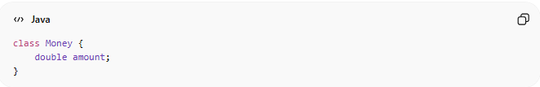
class Money {
double amount;
}
✅ Immutable (usually)
✅ Compared by value

3️⃣ Domain Model
# Source: AI Source: Provided by: [Data Path: Persons Table -> ID Column: 1, Name_En Column: Motasem Essam] -> From: [ChatGPT] on [1/23/2026]
Represents the core business logic and rules
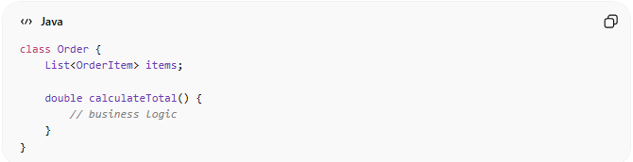
class Order {
List<OrderItem> items;

double calculateTotal() {
// business logic
}
}
✅ Contains behavior
✅ Central to the system

4️⃣ Data Transfer Object (DTO)
# Source: AI Source: Provided by: [Data Path: Persons Table -> ID Column: 1, Name_En Column: Motasem Essam] -> From: [ChatGPT] on [1/23/2026]
Used to transfer data between layers or systems
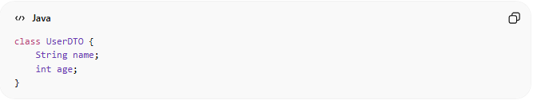
class UserDTO {
String name;
int age;
}
✅ Simple structure
❌ No business logic

5️⃣ View Model
# Source: AI Source: Provided by: [Data Path: Persons Table -> ID Column: 1, Name_En Column: Motasem Essam] -> From: [ChatGPT] on [1/23/2026]
Prepared specifically for the UI layer
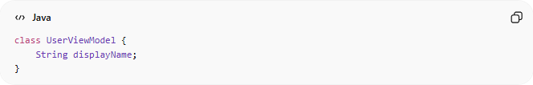
class UserViewModel {
String displayName;
}
✅ Tailored for UI
✅ Combines or formats data

6️⃣ Persistence Model (Entity for DB)
# Source: AI Source: Provided by: [Data Path: Persons Table -> ID Column: 1, Name_En Column: Motasem Essam] -> From: [ChatGPT] on [1/23/2026]
Represents how data is stored in the database
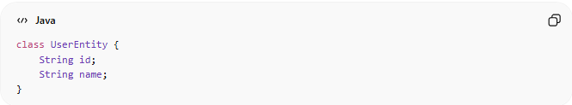
class UserEntity {
String id;
String name;
}
👉 May differ from domain model

7️⃣ API Model (Request/Response Model)
# Source: AI Source: Provided by: [Data Path: Persons Table -> ID Column: 1, Name_En Column: Motasem Essam] -> From: [ChatGPT] on [1/23/2026]
Used for communication with external systems (APIs)
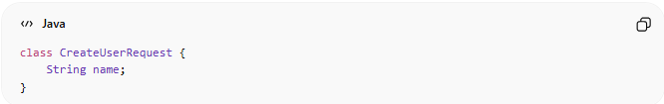
class CreateUserRequest {
String name;
}
✅ Used in controllers/APIs
✅ Matches request/response format

🧱 Relationship Between Models
# Source: AI Source: Provided by: [Data Path: Persons Table -> ID Column: 1, Name_En Column: Motasem Essam] -> From: [ChatGPT] on [1/23/2026]
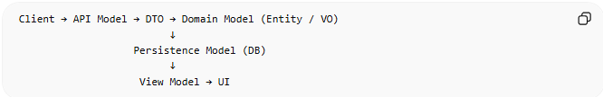
Client → API Model → DTO → Domain Model (Entity / VO)
↓
Persistence Model (DB)
↓
View Model → UI

❌ Common Mistake
# Source: AI Source: Provided by: [Data Path: Persons Table -> ID Column: 1, Name_En Column: Motasem Essam] -> From: [ChatGPT] on [1/23/2026]
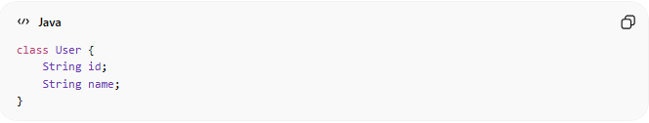
Using one model for everything ❌
class User {
String id;
String name;
}
👉 Leads to:
Tight coupling
Hard to maintain
Poor scalability

✅ Good Practice
# Source: AI Source: Provided by: [Data Path: Persons Table -> ID Column: 1, Name_En Column: Motasem Essam] -> From: [ChatGPT] on [1/23/2026]
Use different models for different responsibilities
👉 Separation = clean architecture

💡 Key Idea
# Source: AI Source: Provided by: [Data Path: Persons Table -> ID Column: 1, Name_En Column: Motasem Essam] -> From: [ChatGPT] on [1/23/2026]
Each model type has one responsibility — don’t mix them

🧾 Summary
# Source: AI Source: Provided by: [Data Path: Persons Table -> ID Column: 1, Name_En Column: Motasem Essam] -> From: [ChatGPT] on [1/23/2026]
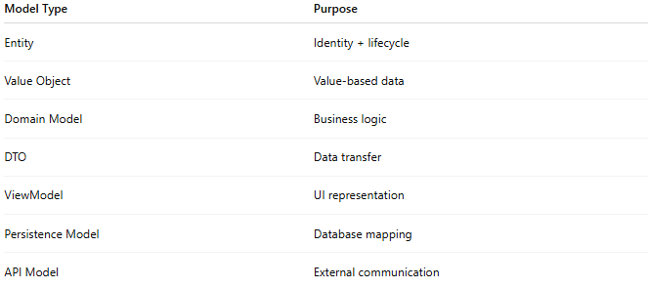
Model Type | Purpose
Entity | Identity + lifecycle
Value Object | Value-based data
Domain Model | Business logic
DTO | Data transfer
ViewModel | UI representation
Persistence Model | Database mapping
API Model | External communication

If you want, I can create a visual diagram showing how all these models interact in a real project (MVC / Clean Architecture) — that’s the missing piece for mastering this 🔥

🧱 Example
# Source: AI Source: Provided by: [Data Path: Persons Table -> ID Column: 1, Name_En Column: Motasem Essam] -> From: [ChatGPT] on [1/23/2026]
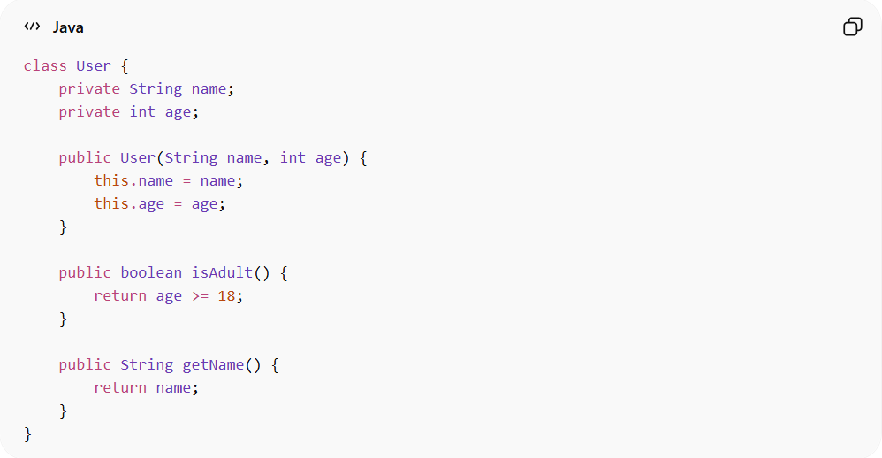
class User {
private String name;
private int age;

public User(String name, int age) {
this.name = name;
this.age = age;
}

public boolean isAdult() {
return age >= 18;
}

public String getName() {
return name;
}
}
👉 Here:
- User is the Model
- It contains data (name, age)
- It also contains logic (isAdult)

❌ Bad Example (Weak Model)
# Source: AI Source: Provided by: [Data Path: Persons Table -> ID Column: 1, Name_En Column: Motasem Essam] -> From: [ChatGPT] on [1/23/2026]
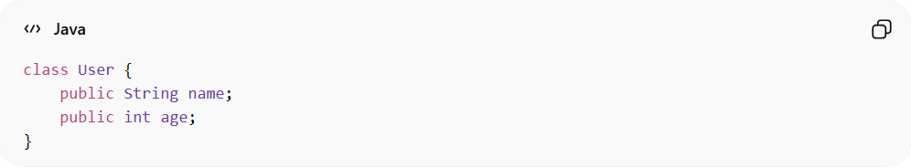
class User {
public String name;
public int age;
}
👉 Problems:
- No encapsulation
- No business logic
- Just a data container

✅ Good Example (Rich Model)
# Source: AI Source: Provided by: [Data Path: Persons Table -> ID Column: 1, Name_En Column: Motasem Essam] -> From: [ChatGPT] on [1/23/2026]
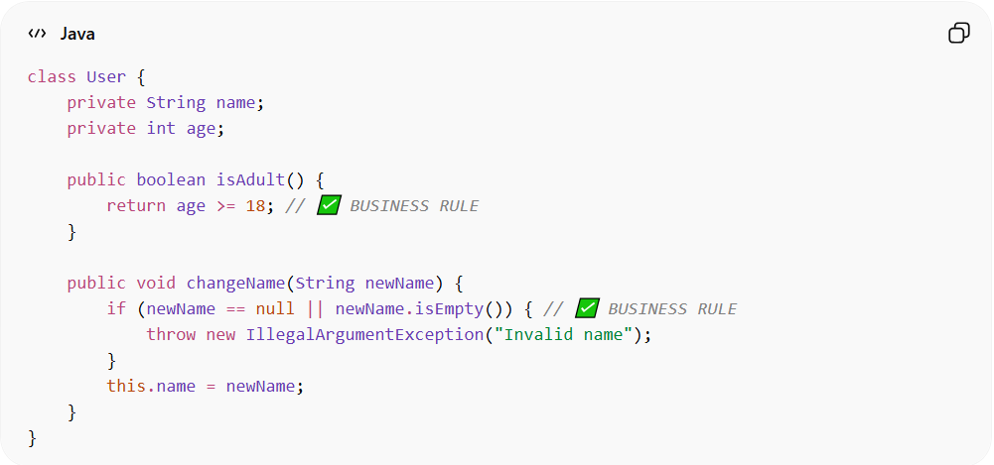
class User {
private String name;
private int age;

public boolean isAdult() {
return age >= 18;
}

public void changeName(String newName) {
if (newName == null || newName.isEmpty()) {
throw new IllegalArgumentException("Invalid name");
}
this.name = newName;
}
}
👉 Benefits:
- Encapsulation
- Business rules inside the model
- Safer and more maintainable

🔄 Model in Different Patterns
# Source: AI Source: Provided by: [Data Path: Persons Table -> ID Column: 1, Name_En Column: Motasem Essam] -> From: [ChatGPT] on [1/23/2026]
- MVC → Model holds data + logic
- MVVM → Model provides raw data, ViewModel prepares it
- DDD → Model becomes rich domain objects (Entities, Value Objects)

⚠️ Common Mistakes
# Source: AI Source: Provided by: [Data Path: Persons Table -> ID Column: 1, Name_En Column: Motasem Essam] -> From: [ChatGPT] on [1/23/2026]
- Turning Model into just a data structure (DTO only)
- Putting business logic in Controller or View instead
- Exposing fields directly (breaking encapsulation)

💡 Key Idea
# Source: AI Source: Provided by: [Data Path: Persons Table -> ID Column: 1, Name_En Column: Motasem Essam] -> From: [ChatGPT] on [1/23/2026]
The Model should not just store data — it should own the business logic related to that data

🧾 Summary
# Source: AI Source: Provided by: [Data Path: Persons Table -> ID Column: 1, Name_En Column: Motasem Essam] -> From: [ChatGPT] on [1/23/2026]
The Model:
- Represents data + business rules
- Is independent of UI
- Is the core of the system design

If you want, I can continue with View, Controller, ViewModel, Repository, Service in the same structured format so your docs folder becomes complete 🔥

